**Installing the JDK**

Before you can install NetBeans, it will first be necessary to download and install the Java Development Kit which contains the necessary files and programs for creating Java programs of our own. This class uses Java 11 and even if you have a more recent version of the JDK installed on your computer you should still install the JDK for that version of Java.

An open source version of JDK (11.41.23) is available from Azul Systems: <https://www.azul.com/downloads/zulu-community/?version=java-11-lts&architecture=x86-64-bit&package=jdk>. While you can install the files manually, it is suggested that you use the installer (.msi link for Windows users and .dmg link for Mac users) version to minimize problems.

When downloading the JDK make sure to choose the download appropriate for your operating system. If there are multiple options available, you will want to download the "x64" version of the JDK which is intended for use with 64-bit operating systems.

Once you have downloaded the appropriate installer, run it and follow the steps. The default settings are fine to use.

**Installing NetBeans**

NetBeans is already installed on all of the PCs in the QBB, but because it is free open source software you can obtain a copy of the program for your own person use for free. The computer labs are using version 12 of NetBeans which can be downloaded from the Apache Foundation. The following URL contains installers for all major operating systems including Windows, MacOS X, and Linux: <https://netbeans.apache.org/download/nb120/nb120.html>

Run the installer once it has finished downloading. Once again, the default install location is acceptable for you to use.

**Installing Subversion**

NetBeans 12 does not come with a Subversion client, so it is necessary to download and install a separate client that NetBeans can use. If you have an Apple computer, Subversion is shipped with the operating system, but may not be activated. To test if it is activated (or install it in the case that it hasn't been) open the Terminal application and type "svn --version" into the terminal and hit the return key. If it has already been activated it will display a small bit of information and no additional information is necessary. If it hasn't, you will be prompted to install the necessary developer components. After that, no additional steps are necessary. More recent versions of the Mac OS may not have command line tools installed by default. In this case type “xcode-select install” into your terminal. You may be prompted to enter your password as a part of this process.

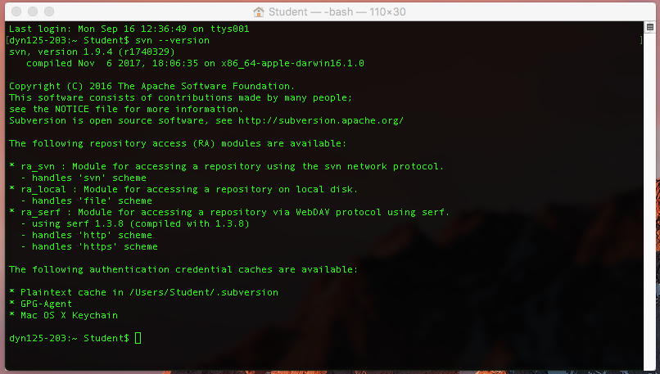

If you are using Microsoft Windows it is recommended that you download TortoiseSVN (<https://tortoisesvn.net/downloads.html>) and choose to install the command line client tools as part of the installation. If you have already previous installed TortoiseSVN you can rerun the installer and choose to modify the installation. When selecting the features to be installed, make sure to change the command line client tools from "Entire feature will be unavailable" to "Will be installed on local hard drive" as shown in the image below. After that, no additional steps are necessary.

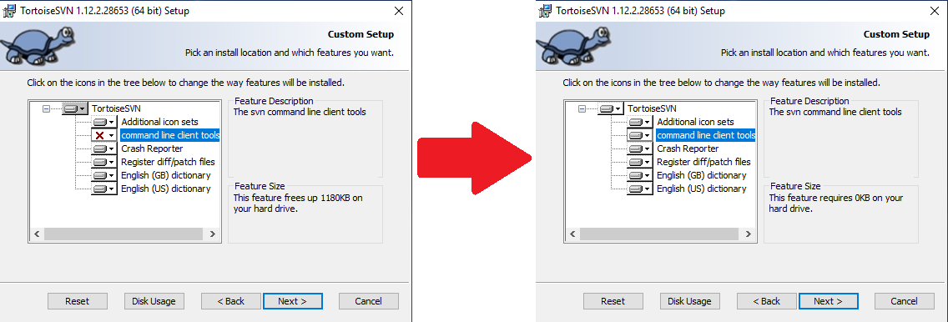

**Downloading Additional Plug-ins: Starting A Project**

When using NetBeans for the first time, you may be asked to install additional plug-ins or modules that the system needs. You will only need to do this once, as once activated, they will remain so.

NetBeans is capable of creating the skeleton of a project from scratch. To do so, select **New Project…** from the File menu or click the New Project button in toolbar or use the keyboard shortcut Control + Shift + N. This will open the New Project Wizard. Under the Categories list, select the Java with Ant option and then in the Projects list immediately to the right select the Java Application option and click the **Next >** Button at the bottom of the window.

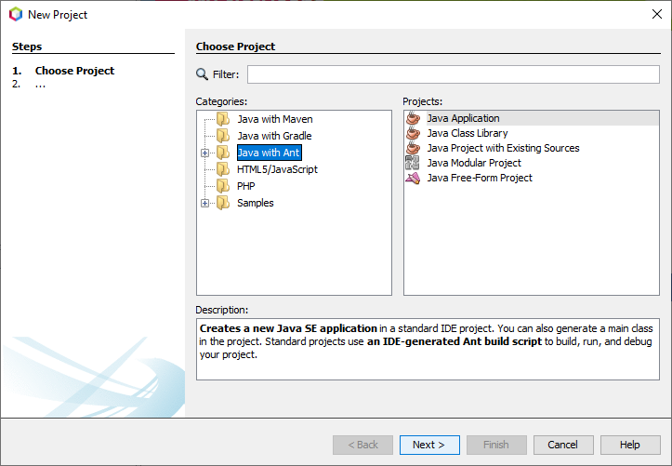

On the next screen you will be prompted to enter a name for the project being created and are also able to change where the project's files will be locally stored on your computer. By default, files will be stored in the Documents\NetBeansProjects directory associated with your user account. Once you chosen a name for your project and made any adjustments to where the files will be stored, click on the **Finish** Button at the bottom of the window once again. This will prompt NetBeans to download any additional plug-ins that are missing.

**Additional Configuration of NetBeans**

If you have installed older versions of NetBeans or the JDK it may be necessary to configure NetBeans to use version 11 of the JDK or it may default to some previously installed version. To change the default Java Platform that NetBeans uses for all projects, it is necessary to get into the Options. To do this on Windows, select the Tools menu and then **Options** at the bottom. On a Mac, select NetBeans from the menu at the top of the screen and then **Preferences...**

Once the Options window is open, choose Java from the row of icons at the top of the window. Below that, select the Java Shell option. If the Java Platform is listed as JDK 11 (or something similar) you do not need to make additional changes. If it is not, check to see if JDK 11 is listed in the drop-down menu. If it is not, click the **Manage...** button to the right to add it.

Click the **Add Platform** button towards the lower-left corner of the window. Select Java Standard Edition if it isn’t already selected and click the **Next** button in the Add Java Platform pop-up windows. Find the location for the JDK that you installed. On a Windows PC this should be C:\Program Files\Zulu\zulu11.41.23-ca-jdk11.0.8-win_x64 (or something similar) and on a Mac this should be /Library/Java/JavaVirtualMachines/zulu-11.jdk/Contents/Home. After selecting the correct file/path, click the **Next** button and provide a name such as JDK 11 and click the **Finish** button.

Select the newly added JDK 11 Platform from the drop-down menu and click the **Apply** button. NetBeans should default to using version 11 of the JDK now.